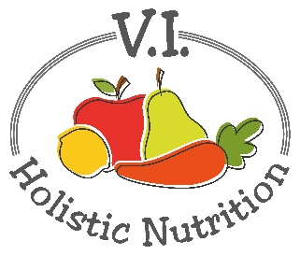
MINTY SUNSHINE
This juice was adapted from 5lbs in 5 DAYS by Jason Vale. I have adapted it by making 2 juice bases at once and using mint leaves and ice cubes in a blender to finish it. (makes 2 juices)
Ingredients (base)
- 4 large juicy oranges, peeled or squeezed by hand to extract juice
- 6 medium carrots
- 1 inch of ginger
Juice all above ingredients and transfer and divide the juice into 2 (2 cup) glass jars and seal and store in the fridge or freeze (if not using it that day).
When you are ready to serve transfer the juice to a blender or NutriBullet and add (per serving):
- 4 sprigs of mint
- 3 ice cubes (made from filtered water) optional
Blend and serve immediately.

