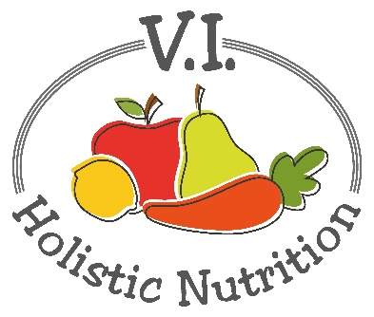
SWEET BEET SMOOTHIE
This juice was adapted from 5lbs in 5 DAYS by Jason Vale. I have adapted it by making 2 juice bases at once and using frozen mixed berries in a blender to finish it. (makes 2 juices)
Ingredients (base)
- 2 organic granny smith apples
- 4 carrots
- 2 medium beets
Juice all above ingredients and transfer and divide the juice into 2 (2 cup) glass jars and seal and store in the fridge or freeze (if not using it that day).
When you are ready to serve transfer the juice to a blender or NutriBullet and add (per serving):
- 1 cup frozen mixed berries
Blend and serve immediately.

